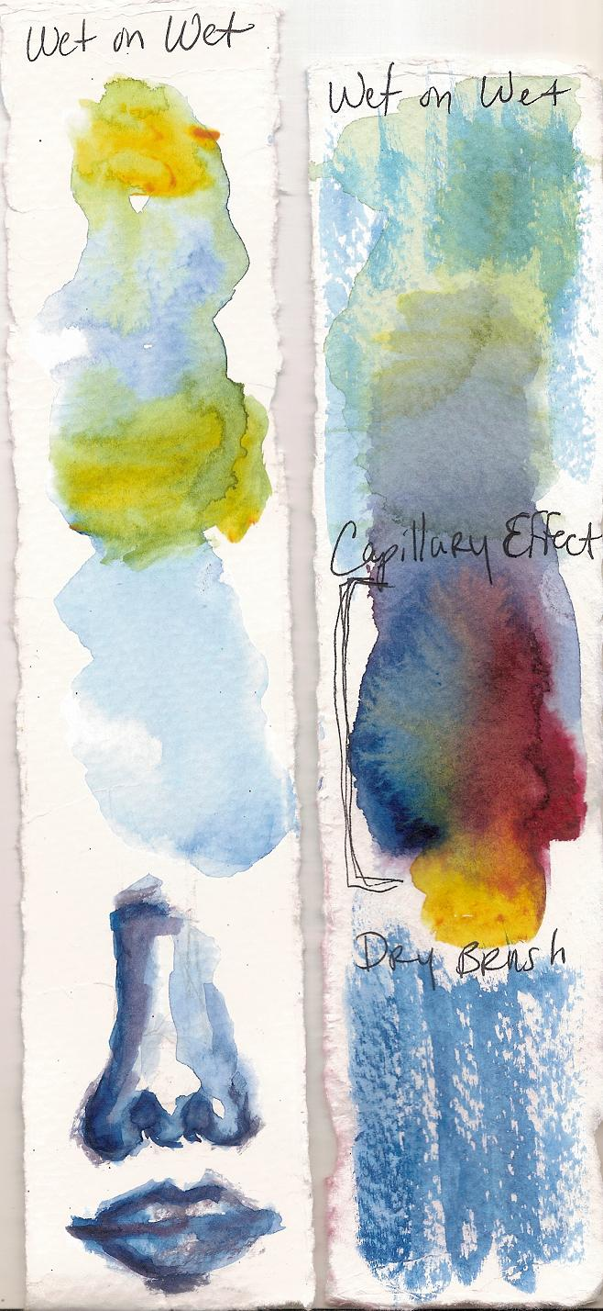
Wet on wet, Capillary Effect, Dry Brush
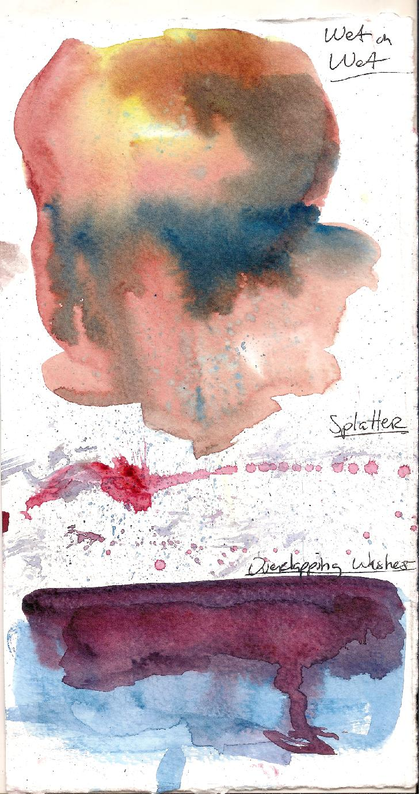
Wet on Wet, Splatter, Overlapping Washes
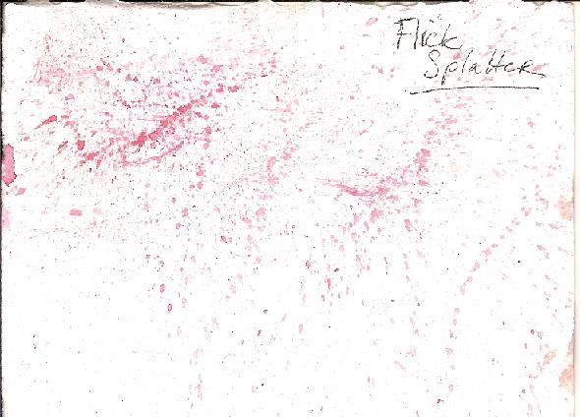
Flick Splatter
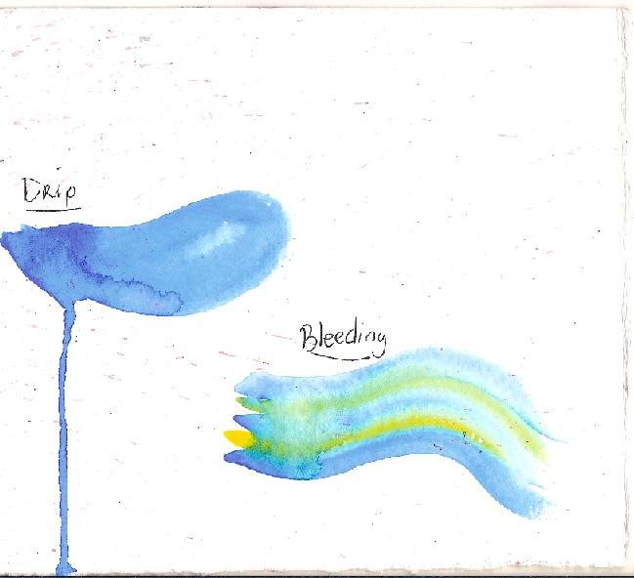
Drip and bleeding

