Sample Art Product
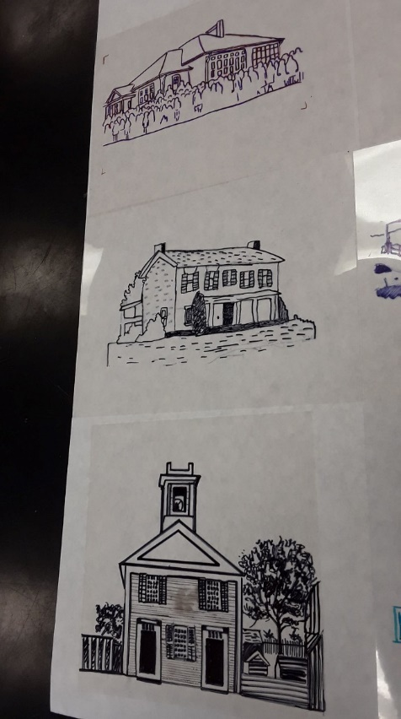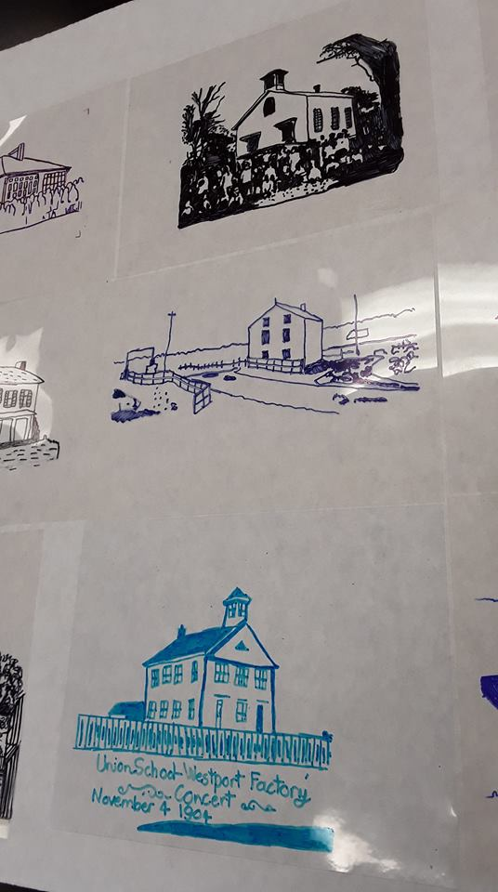
Step one: drawings on transparencies
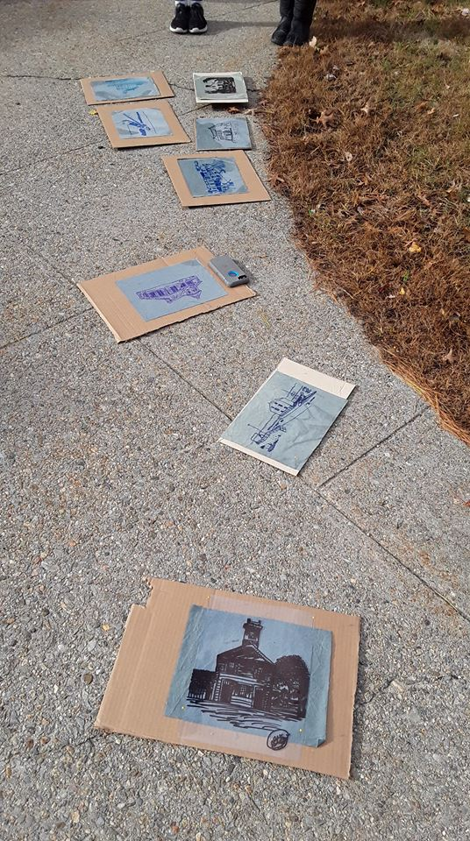
Step 2: Work Stations (carboard base, fabric, transparency drawing pinned on-top)
Exposure times: refer to lesson and cyanotype process reference page
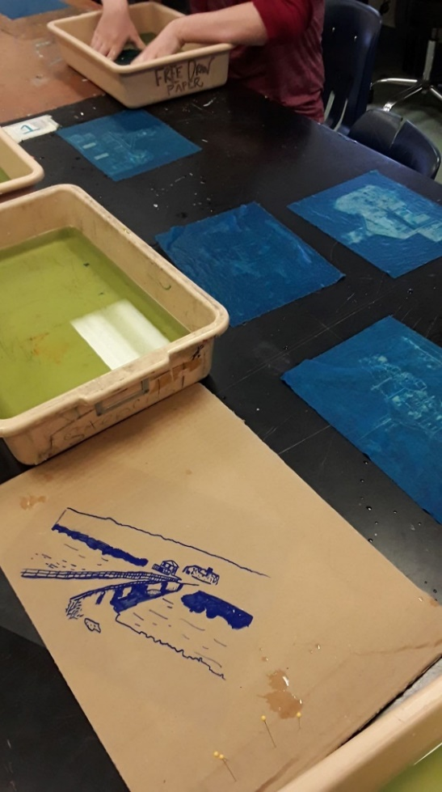
Step 3: Rinse fabric in water baths
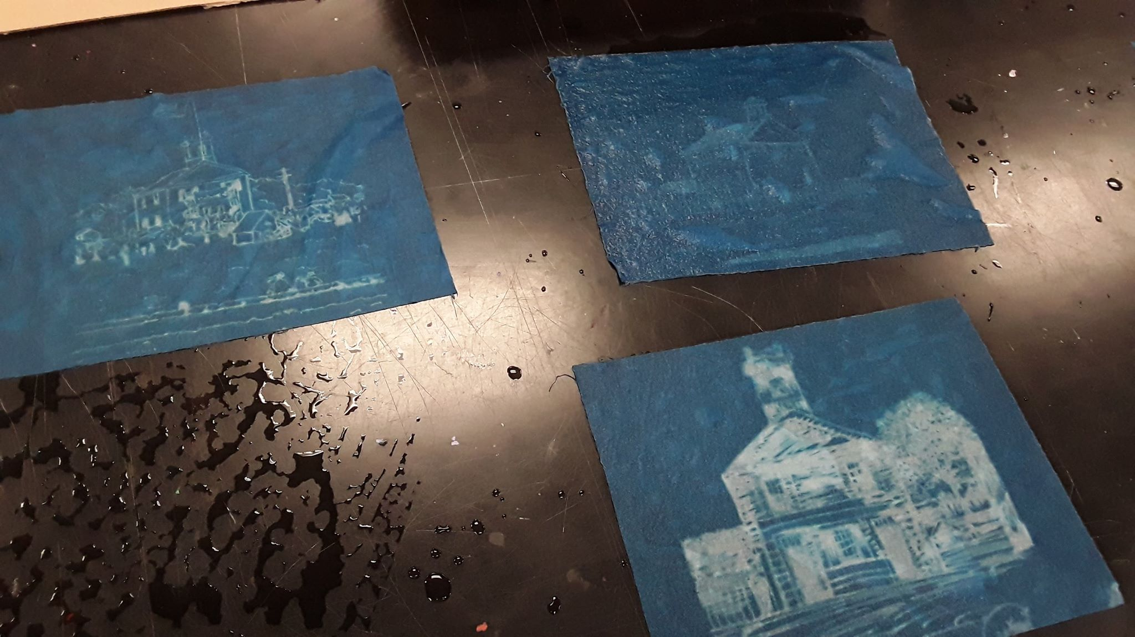
Step 4: Drying fabric

