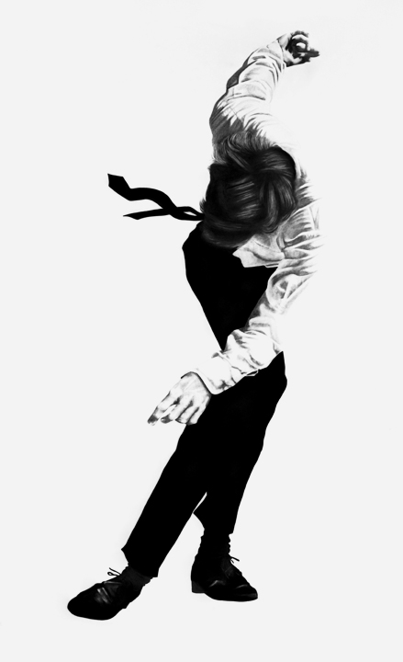
Untitled
1981
Charcoal and graphite on paper
96 x 60 inches/243.8 x 152.4 cm
Vanmoerkerke Collection, Belgium
http://www.robertlongo.com/portfolios/1030/works/32554

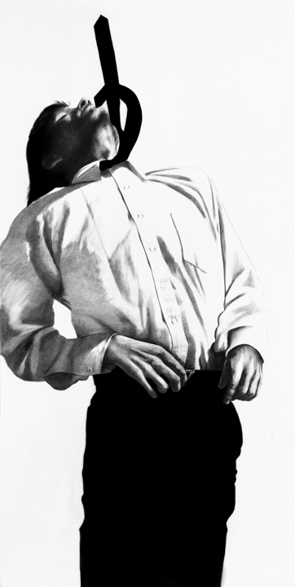
Untitled
1982
Charcoal and graphite on paper
96 x 48 inches/238.8 x 121.9 cm
Collection Gerald S. Elliott
Chicago, IL
http://www.robertlongo.com/portfolios/1030/works/32559

Untitled
1982
Charcoal, graphite, oil and ink on paper
96 x 48 inches/238.8 x 121.9 cm
Collection Victoria and Albert Killeen
Atlanta, GA
http://www.robertlongo.com/portfolios/1030/works/32562

