Cyanotype Printing Process

What is a cyanotype?

Cyanotype is an antique photographic printing process, developed in the mid 1800’s and distinctive for its rich blue color. When the cyanotype fabric is exposed to sunlight, a chemical reaction occurs. It won’t reveal itself until you put the fabric in water. Then it will instantly turn blue!

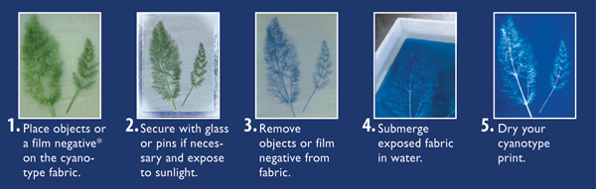

**Mixing chemicals**The cyanotype is made up of two simple solutions.

* Potassium ferricyanide and Ferric ammonium citrate (green) are mixed with water separately.
* The two solutions are then blended together in equal parts.

(We will be using cotton fabric sheets that are already treated with these solutions.)

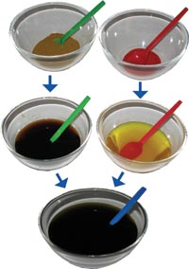

**Preparing the surface**

* Paper, card, fabric or any other naturally absorbent material is coated with the solution and dried in the dark. (this process is already completed with our pre-treated fabric sheets)

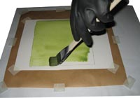

**Printing the cyanotype**

* Objects or negatives are placed on the material to make a print. The cyanotype is printed using UV light, such as the sun or a light box or a UV lamp. The objects or negatives are exposed for about 10 minutes in direct sunlight.

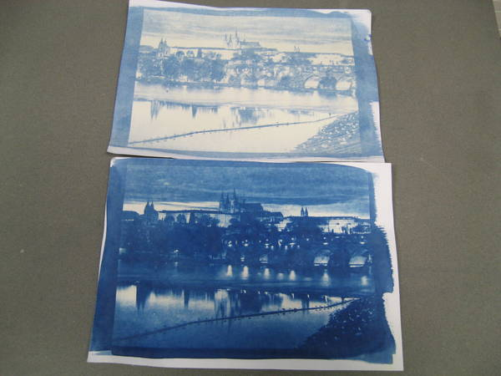

*Cyanotypes with different exposure times*

**Processing and drying**

* After exposure the material is processed by simply rinsing it in water. A white print emerges on a blue background.
* The final print is complete once the surface has dried.