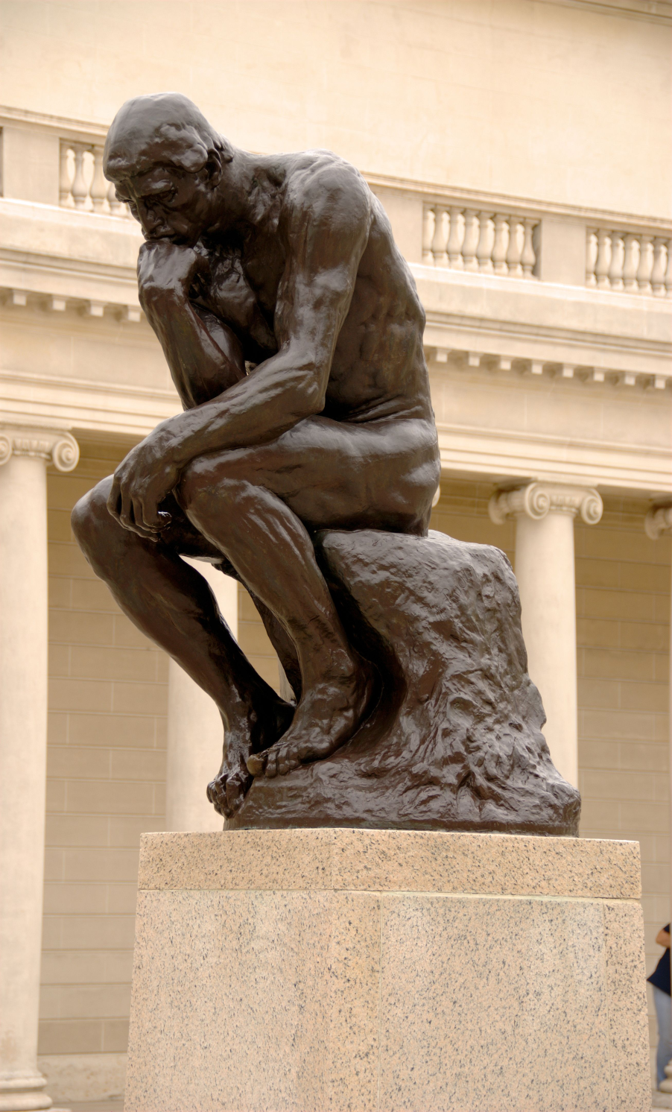
Auguste Rodin
The Thinker
1902
Google Images: http://commons.wikimedia.org/wiki/File:The_Thinker,_Auguste_Rodin.jpg

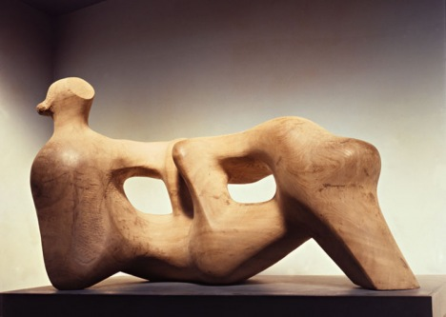
Henry Moore
Reclining Figure
1976-1978
Google images: http://www.tate.org.uk/whats-on/tate-britain/exhibition/henry-moore-0/henry-moore-room-guide/henry-moore-room-7

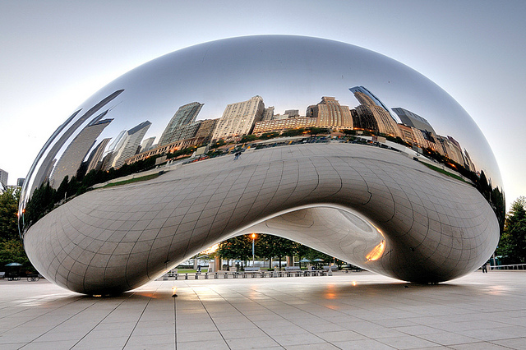Anish Kapoor
Cloud gate
2006
Google Images: http://culturalcapitol.com/2009/12/04/anish-kapoors-cloud-gate-millennium-park-chicago/

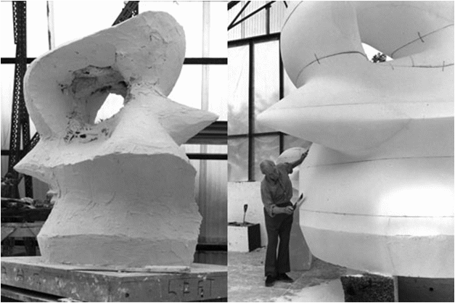Henry Moore working with plaster in studio
1968-1969
Google images: http://www.leslieparke.com/tag/bronze-sculpture/
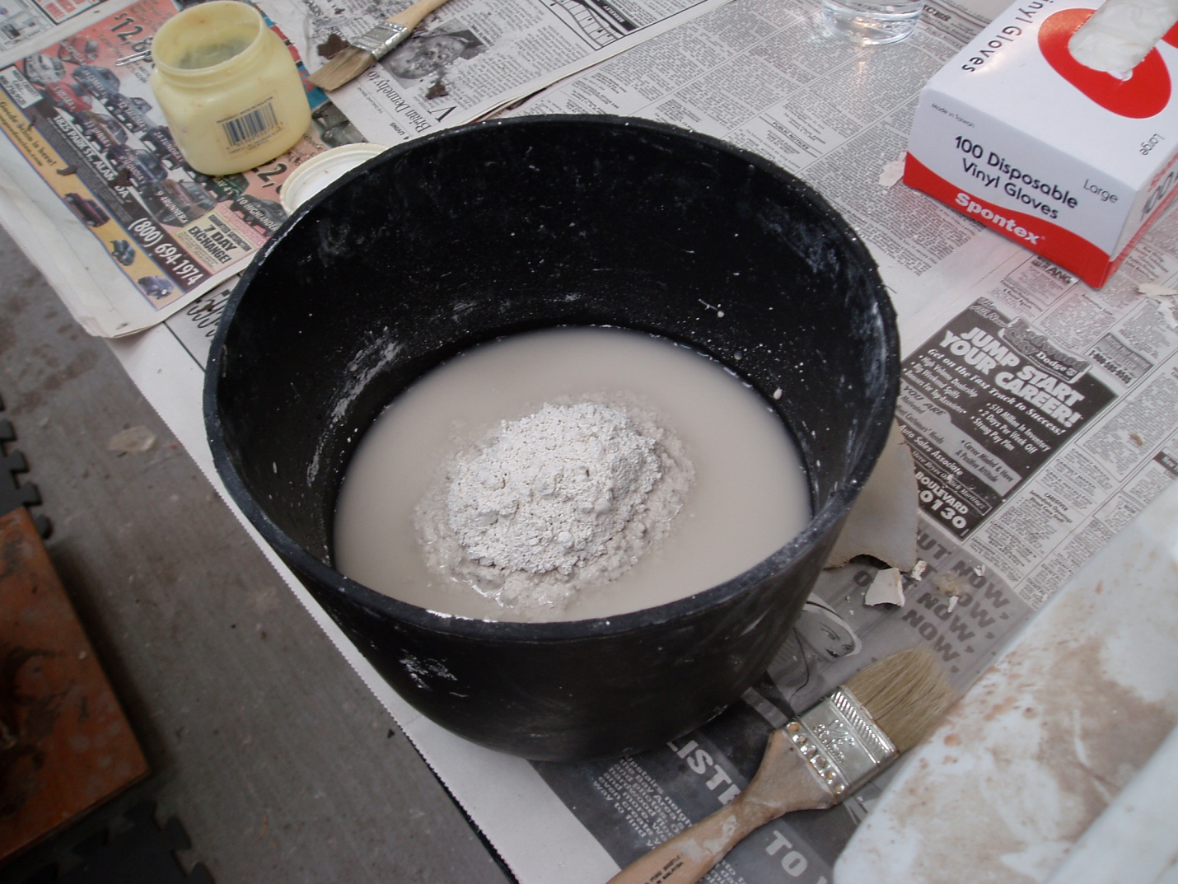Moutain or Island method example
Google images: https://vzmolds.wordpress.com/2011/05/25/mixing-plaster-of-any-kind/olympus-digital-camera-34/
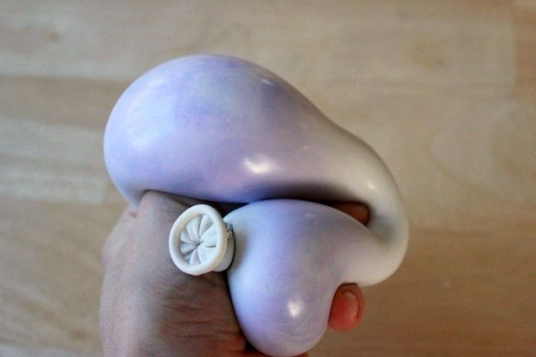Balloon example
Google images: http://artfulparent.com/2014/01/plaster-balloon-sculptures-with-kids.html

